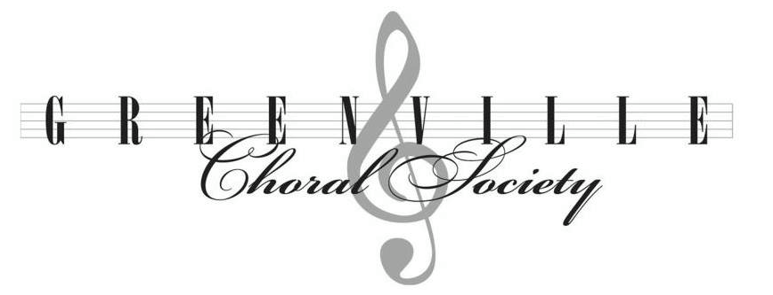

Luke Hancock, Director
Cell: (252) 294-6002
Remind Code: @gcsyo
Email: gcsyouthchorale@gmail.com
Website: www.greenvillechoralsociety.com

16 September 2018

Dear Students and Parents,
Welcome and welcome back! We are very excited that you have decided to be a part of this year’s Greenville Choral Society Youth Chorale. Below you will find all expectations, procedures, fees, etc. for members and their families. Please make sure to read everything and sign and return the bottom portion, along with semester dues, and conflict calendars no later than the 3rd rehearsal (Sun. 10/7). We are looking forward to a great year together!

Best,
Luke Hancock, Youth Chorale Director

Attendance:
- Members can miss no more than 3 rehearsals per semester.
- Arriving late or leaving rehearsals early will count as a tardy. 3 tardies will equal 1 absence.
- Students/parents should fill out the attached Conflict Calendar with all known absences and should return it no later than the 3rd rehearsal. Any emergencies should be communicated with the Director immediately.
- Students MUST attend the dress rehearsal in order to participate in the concert. Any issue with this date should be communicated with the Director immediately.
- A failure to meet the attendance requirements will result in not being allowed to perform in the concert.
Fees & Fundraising
- Membership dues are $75/semester. This includes the music.
- Dues can be paid in cash, by check or money order to the Greenville Choral Society (please make sure to put the student name in the memo line), or can be paid online at www.greenvillechoralsociety.com/fees.
- A limited number of need-based scholarships are available for membership dues. Applications should be completed and returned by 10/7. Please see the Director or General Manager, Paula Mitra for more details.
- Fundraising is a necessary part of any non-profit organization and it is expected that all members participate in our group fundraisers. Keep in mind that many fundraisers include incentives such as free dues!
Materials
- Students will need a non-shiny. solid black 3-ring binder for the concert.
- Students should always have a pencil for each rehearsal.
- Students are encouraged to bring a bottle of water to rehearsals.
Concert Attire
- Ladies – GCS Dress ($64/same as PCS dress), black, closed-toe shoes with little to no heel, and a strand of pearls. Ladies that need a dress will be measured early in the semester and dresses will need to be hemmed.
- Men – Black dress pants, solid black, long-sleeved button up shirt, black socks, black dress shoes, and red GCS tie. GCS will order ties ($15).
Rehearsal Expectations
- Rehearsals will begin on time each week. Students should plan to arrive a few minutes early each week to gather materials so that we may begin right at 2:30. To be early is to be on time, to be on time is to be late!
- Students should be fully engaged at all times during rehearsals. Conversations should be kept to a minimum and students should pay close attention to all instructions given by the Director. Cell phone use will not be tolerated. Our rehearsal time is very precious so we must make sure that we use it wisely!

------------------------------------------------------------------------- Cut Here-------------------------------------------------------------------------

Student Name: _______________________________________

I have read and agree to all expectations and procedures for being a member of the GCS Youth Chorale.

X____________________________________________ ___________
Student Signature Date

X____________________________________________ ___________
Parent/Guardian Signature Date

